CHAPTER 1
INTRODUCTION

1.1 Introduction
This section gives a scope, description and overview of everything included in this Project Report. Also, the purpose of this document is described and the system overview along with the goal and vision are listed.
In everyday life, economics, or investment, market liquidity is an asset’s ability to be sold without causing a significant movement in the price and with minimum loss of value. Money, or cash, is the most liquid asset, and can be used immediately to perform economic actions like buying, selling, paying debt, and meeting immediate wants and needs. According to a survey taken in 2018, still 95% of India is cash-reliant. That means cash in hand is more important for easy going of the system, mostly in places which have heavy population and less resources. Yet most of the times the withdrawal system is not that convenient and ATMs are not available everywhere. Limitation of the number of ATMs or the amount of money available in them creates problems. Most of the time it says ‘out of money’, ‘out of order’ or even sometimes there is no atm nearby. Sometimes the amount is withdrawn from the customer account but the money does not dispense the cash.
The Cashpoint aims to build an alternative to the conventional ATM System and expedite the process of money transfer and focus on improving the finance domain. Everyone today uses the banking system for the transaction of money. The ATM System of the bank gives independence from the long queue and documentations of the bank withdraw counter but still has some limitations like technical or physical issues or lack of money. But Cashpoint resolves most of the problems along with providing some new facilities and a more easy approach to the banking system. It eradicates the problem of ‘out of money’ and even of ‘no ATM nearby’. The software can be hosted by any small vendor to a big enterprise.
Though the number of ATM systems is very less, but we have a huge number of small or big businessman and shops who can help. These local businessman or shopkeepers will act as a mediator between bank and bank-customers. The can host the software. The proposed software has a per day transaction amount limit that almost all the shopkeepers can afford. This limit is for both withdraw and deposit, above which the software will not allow any further transactions. Apart from this they will also receive deposits and can give the withdrawal amount from the deposits they received. Hence the system flow will be easy and smooth.
All the process is kept secure and up to mark keeping in mind the assurity of transactions and all real-world failures that may arise. The system of the transaction of money using Cashpoint is designed in the most innovative, easy and secure manner.
Working on the bank server, the application will keep a record of all the activities and will also limit access wherever necessary. The owner/admin/host of the cashpoint will receive the deposit and give the withdrawal to the bank-customer and each activity will be recorded on the bank server. In the end net balance of the amount received and given will be settled by the bank. The owner/admin/host has several provisions and also some limitations for the proper functioning of the system.
The use of this software and such reform is strongly recommended to improve and expedite the banking system and all financial activities.

  - Identification of Problem Domain
Financial activities need to be strong, strict and secure. But still somewhere there remains some flaw in the system flow. ATM System has many technical and physical problems. Whether it software problem of any runtime problem. Most of the time they are not even present in all the places to facilitate the customers. Limitation of the number of ATMs or the amount of money available in them creates problems. Most of the time it says ‘out of money’, ‘out of order’ or even sometimes there is no ATM nearby. Sometimes the amount is withdrawn from the customer account but the money does not dispense the cash. ATMs also have physical problems such as worn-out ATM cards, broken keypad, or receipt malfunctions.
The lack of ATMs is the first and biggest problem. Banks don’t have adequate numbers of ATM systems. Although most of the transactions are supposed to be done by ATM systems to reticulate the process, make it faster and reduce the dependency on the bank for just withdrawal of cash. But stills it seems that hosting of ATM systems and maintaining them is a big deal for banks.
In business market liquidity is an asset’s ability to be sold without causing a significant movement in the price and with minimum loss of value. Money, or cash, is the most liquid asset, and can be used immediately to perform economic actions and meeting immediate wants and needs. According to a survey taken in 2018, still 95% of India is cash-reliant. That means cash in hand is more important for easy going of the system, mostly in places which have heavy population and less resources. Yet most of the times the withdrawal system is not that convenient and ATMs are not available everywhere. Limitation of the number of ATMs or the amount of money available in them creates problems. Most of the time it says ‘out of money’, ‘out of order’ or even sometimes there is no atm nearby. Sometimes the amount is withdrawn from the customer account but the money does not dispense the cash.
CHAPTER 2
LITERATURE REVIEW

2.1 LITERATURE REVIEW
This section describes the various projects we studied before starting the development of our project. Although the concept of this project is completely new and there has been no such software like this that does cross our vision till now. Our project is for the local banks and accounts for cash to be received and given in hand. Though this domain has some similar other software that can be studied to understand the domain. We have discussed the features, advantages and disadvantages of the various projects and how we learnt from them and made our own project.
2.1.1 STUDY OF PAYMENT BANKS
Many of the research papers have explained the objectives of the Reserve Bank of India for the establishment of Payments Banks in the country. The maximum focus among these objectives was on the role of these banks in promoting financial inclusion in the country. The definition of financial inclusion as per CRISIL “The extent of access by all sections of society to formal financial services such as deposit, credit, insurance, and pension services.” There exist three dimensions of financial inclusion, viz., Branch Penetration, Credit Penetration, and Deposit Penetration. “In 2014, only 50% of the adults in India had a bank account”, out of which 40% (highest in the world) were dormant. Also, “the number of ATMs per 100,000 of population was 18 compared to around 50 in Indonesia and 125 in Brazil”. According to the paper “RBI Guidelines for Licensing of Payment Banks: Opportunities and Challenges” , published by Deloitte Touche Tomatsu India Pvt. Ltd., many initiatives have been undertaken by the RBI, the Government of India, and other stakeholders to promote financial inclusion. The primary reason for low levels of financial inclusion in the country despite these initiatives is “the lack of financially viable business models to serve the ‘Bottom of the Pyramid’ customer segment in cost effective manner”. “Payments Banks are niche banks, setup by the Reserve Bank of India to further the agenda of financial inclusion. These banks will provide small savings accounts and payments/ remittance services mainly to migrant labour workforce, low-income households, small businesses, etc. by enabling high volume -low value transactions in deposits and payments/ remittances services in a secured technology-driven environment.”[3]. The biggest impact of the payment bank will come towards the way remittances are being exchanged within the country as sending money in cities and villages will become a lot easier. “The Domestic remittance market grew at an average rate of 10.3% from 2007 to 2013 and is estimated at more than INR 366.11 billion, with 50% contribution bymigrant workers. Around 10% of the population regularly sends money to their families living elsewhere in the country.” Payment Banks can therefore play a pivotal role by capturing market share and facilitating easy remittances. Payment banks in India will ensure that every person with telecom and internet services can avail banking services without any extra charges. They provide a convenient, secure and Cashless mode of transaction. Thus, “digital technology will be the vehicle for banking.”. Also, government has been stressing upon the Digital India initiative which will in a way help in proliferation of payment banks in the country. Payment banks can help the ‘Indian Post’ in delivering the subsidies and other welfare schemes to the needy. “There are over 1.5 Lakh post offices to serve as physical medium for transferring subsidies.” Telecom players such as Vodafone and Airtel will further ease the banking facilities for the customers. All the transactions via a payment bank are recorded and can prove very beneficial to minimize the cash transactions and elimination of black money. “Payment Banks can assist in schemes like Jan Dhan Yojna.”[4]. This might even prove to be an obstacle for the payment banks as the transaction system is quite transparent people might be reluctant to follow this method of transaction. Existing business model of mobile payments involves performing transactions electronically through mobile phones instead of using traditional methods like cheque, cash, debit card, credit card, NEFT, RTGS, etc. According to to use this system, the customer should have an existing phone account with any network operator in the country, and should open an account with any bank available. The customer has to then register this bank account with the mobile Payment Banking service. The key features of this service are:
• Immediate payment service
• Instant fund transfer
• Any time any day availability
• Simple and easy to use
• Inexpensive, fast and safe to use
• Accessible globally
“In India, about 40% of the population is still unbanked; to touch these people mobile payment was launched but after this long year we find they are still uncomfortable with this banking system. In which customer can transfer money or pay for goods and services by sending SMS, using application or any other mobile communication technology.” It was mentioned that the problem lay in the usability, cost, interoperability, and security of transaction and that to solve these problems, the Payments Banks System was proposed by the RBI. Some of the important guidelines provided by RBI to setup payment banks are:
• Payment banks can accept demand deposits up to Rs.1,00,000
• They can issue ATM/ debit cards/ prepaid payment instruments
• They can offer internet banking services
• They can offer payment/ remittance services
• They can offer payment of utility bills
• They cannot undertake lending activities or issue credit cards
• The minimum paid up capital is fixed at Rs.100Cr and the payment banks need to maintain a minimum leverage ratio of 3%.
• At least 25% of the access points should be established in the rural regions.
• At least 75% of the deposits need to be saved in SLR based securities, i.e. government bonds. The rest 25% can be saved as deposits in other banks.
2.2 LIMITATIONS OF EXISTING SYSTEM
The new payment banks have come into the play due to repeated efforts from RBI and conventional financial banks for financial inclusion have failed in rural areas, due to which RBI has decided to issue licenses for payment banks. The concept and players are relatively new, however only the positive aspects are focused upon. The negative aspects which may arise due to increasing competition or sour attitude of traditional banks due to missing out on a new avenue or a business opportunity has been looked over. At the same time expertise of finance lie concentrated with these banks, the new market entrants, not necessarily from financial backgrounds will need time and patience to get growth in a relatively lowprofit sector which will survive entirely on the high volume of transactions thus maximizing the risk for everyone involved. Benefits to payment banks in the entire process are not clearly specified and remain slightly vague. Certain amount is earned by the payment bank per transaction but no clarity as to what amount it is and what exactly is the source of it. Also, credit restrictions imposed by the RBI on payment banks restricts the growth and this being a relatively new sector not much research is conducted on how exactly the growth trend or strategy of payment banks would be due to lack of examples. What next? Is a question which has entirely been ignored in the researches? If financial inclusion is successful with eh help of payment banks, RBI has not given any vision regarding the next step which would primarily help such organisations to know which direction to adopt and how to grow. The research papers do not consider a holistic view of all the effects of payment banks. Research is confined primarily to objective of financial inclusions. Other important objectives which may include reduction of black money, promotion of digital India campaign is not focused on. Also, demonetization and the adoption of cashless economy go hand in hand but no such linkages have been focused upon. Its effect or mode of implication to continue reduction of black money has not been focused on as well. All these outcomes of this process must be studied collectively to be in a better position to predict or plan the future which is crucial for the economy of India.Payment banks have just started beginning their operations in the country with Airtel already having launched their product and Paytm on its path to launch one soon. This lack of information is a limitation to the research due to lack of experiences and exposure. The output of payment banks in other developing countries such as Kenya may not be the same in India. Therefore, it’s only possible to speculate the system by experts and accordingly prepare for it. Also, therefore RBI also would not be able to shape policies perfectly and may have to constantly modify and improvise on them to better suit the smooth functioning of the system. This radical role RBI will play is also not focused upon. This possibility of modifying policies left completely at the discretion of RBI may serve as a risk to both payment banks and conventional banks and has been completely overlooked in research papers.

CHAPTER 3
RATIONALE AND PROCESS

3.1 OBJECTIVE
The main objective of this project is to provide a fast and powerful alternative to the conventional banking system. To brisk the process of transactions and to reduce the reliance on ATMs or bank withdrawal counters. The reliability on the ATMs may reduce the fluency and liquidity in business. Since 95% of India is still cash-reliant, and if these ATMs don’t have money or are out of order, then it can create a big problem. Demonetisation has taught us to use more and more cashless transactions. But small cities of country are not ready yet for this. And these are the only ones which also have less access to ATMs or banks.
This software focuses more on the real-world problems rather than just solving the previous issues with any other software, because there has been no such previous system. So it is moreover a complete new system, implemented with the help of this project.
This project helps people who need cash from there bank but don’t want to waste time in queue of bank-withdrawal counter or want to search for an ATM of their bank, that too in service. They can just go to any nearby shop that host this software for the bank and can withdraw that amount from there account through them. Just like withdrawal they can also deposit amount in there account through this. Not only withdrawal or deposit but the software can accomplish all the facilities like “check balance”, “change pin”, “mini-statement”, “fast cash”. Here the host of the software is just a mediator between customer and bank.
The software has different login facilities for both bank-customers and host. Although for bank-customer, login credentials are his name, card number and atm pin. This software does not have login or any other scope for the bank admin to avoid security issues. In one sense both the customer and host are client user of the software and do not have any administrative facilities.
The objective is to provide good customer relationships by providing a good and friendly user interface which will make the application very easy to use.
The other objectives are to developing or improving knowledge such as competitive intelligence. In many cases, knowledge is an objective but not an end goal. For example, feasibility studies for a new technology. The integration is also a goal to connecting things and getting them work together.

3.2 softwAre model adapted
We are using RAD (Rapid Application Development) Model for our project. This is an incremental model with a focus on parallel development work. The reason for choosing this model is because this model is good for developing project in 2-3 months. And also we were working for front end and back end part in parallel. Also this model helped us gain reviews and understanding what we are trying to achieve is possible or not sooner so that we can deal with any issue very soon.

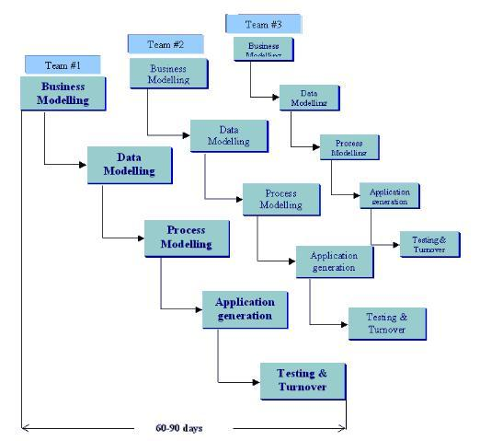
Figure 3.1: RAD Model Diagram

The phases in the rapid application development (RAD) model are:

Business modeling: The information flow is identified between various business
functions. Similarly we identified the main functions of our project and how
information will flow between those functions.
Data modeling: Information gathered from business modeling is used to define data
objects that are needed for the business. Same way we created data objects of what
information we have to store and transmit.
Process modeling: Data objects defined in data modeling are converted to achieve the
business information flow to achieve some specific business objective. Description are
identified and created for CRUD of data objects. We identified the working of each of
our primary modules and created process models so that we can easily convert them to
code.
Application generation: Automated tools are used to convert process models into
code and the actual system. We didn’t have much access to automated tools.

Testing and turnover: Test new components and all the interfaces. After preparation
of a module or an essential component, we tested it out and also after integrating one
or more components.

We researched for our front end and backend part separately. Also we started the design and development part separately for both. We started coding and testing the
backend to see whether it will satisfy our project’s objective and also the interface separately to make it as much user-friendly as possible. We gained results very fast as soon as we got hold of the technology we are using.

Also the interface we have built can be easily changed and we will get an interface for another application. Thus it is very much modularized. Also our backend code can be reused with some minor changes in another location based application. The thing we had to keep in mind is that we can keep much work independent as possible so that we have reduced dependency between front end and back end. Also we can later add new functionalities in the application with ease because of its incremental nature.

CHAPTER 4
SYSTEM ANALYSIS OVERVIEW
4.1 REQUIREMENT ANALYSIS
In software engineering, requirement analysis focuses on the tasks that determine the needs or conditions to meet the new or altered product or project, taking account of the possibly conflicting requirements of the various stakeholders, analyzing, documenting, validating and managing software or system requirements.
4.1.1 HARDWARE REQUIREMENTS
To be used efficiently, all computer software needs certain hardware components or other software resources to be present on a computer.
Our application demands some hardware requirements which include, Minimum 1 Giga Bytes of RAM. This software is developed on java so the system requires a java runtime environment to run the software. Since java is platform independent the application will work on all the operating systems which have JRE 8 or higher. Hardware requirements include a computer system with keyboard, screen and printer; and internet connectivity in case of mobile database access.
The above hardware requirements will be enough to run this application on anyone’s mobile phone.
4.1.2 SOFTWARE REQUIREMENTS
This software is developed on java so the system requires a java runtime environment to run the software. Since java is platform independent the application will work on all the operating systems which have JRE 8 or higher. If the above software and hardware requirements are fulfilled, the application will be able to run and work satisfactorily.
4.1.3 FUNCTIONAL AND NON-FUNCTIONAL REQUIREMENTS

The software focuses on the finance domain and the banking system. It is made ready to be used in the real-world as an alternative to ATM. If the proposed system is applied precisely, it will bring reform in the banking and finance system and will have a great impact making the transfer of money much easy and fast. Small villages or towns which have fewer ATMs available or face the problem of lack of money will get a huge advantage from this system. At present, no such system is in use

The main functional requirement of the project is in fulfilling the huge requirement of cash availability in most of the areas of countries where cashless transaction is still not adopted. Additionally, it will also ease the transactions with bank and reduce the dependency over atm systems and bank withdrawal or deposit counters.

It provides all the functionalities that an ATM system provides, from withdrawal to deposit, checking mini-statement and even change pin. With full security and least chances of any failure.

It provides separate administrative services for the host which includes checking history, checking history of a particular card holder and calculate the net total from the amount host gave as withdrawal to the customer and received as deposit.

4.2 USE-CASE DIAGRAM AND USE-CASE DESCRIPTION
A use case diagram at its simplest is a representation of a user's interaction with the system that shows the relationship between the user and the different use cases in which the user is involved.

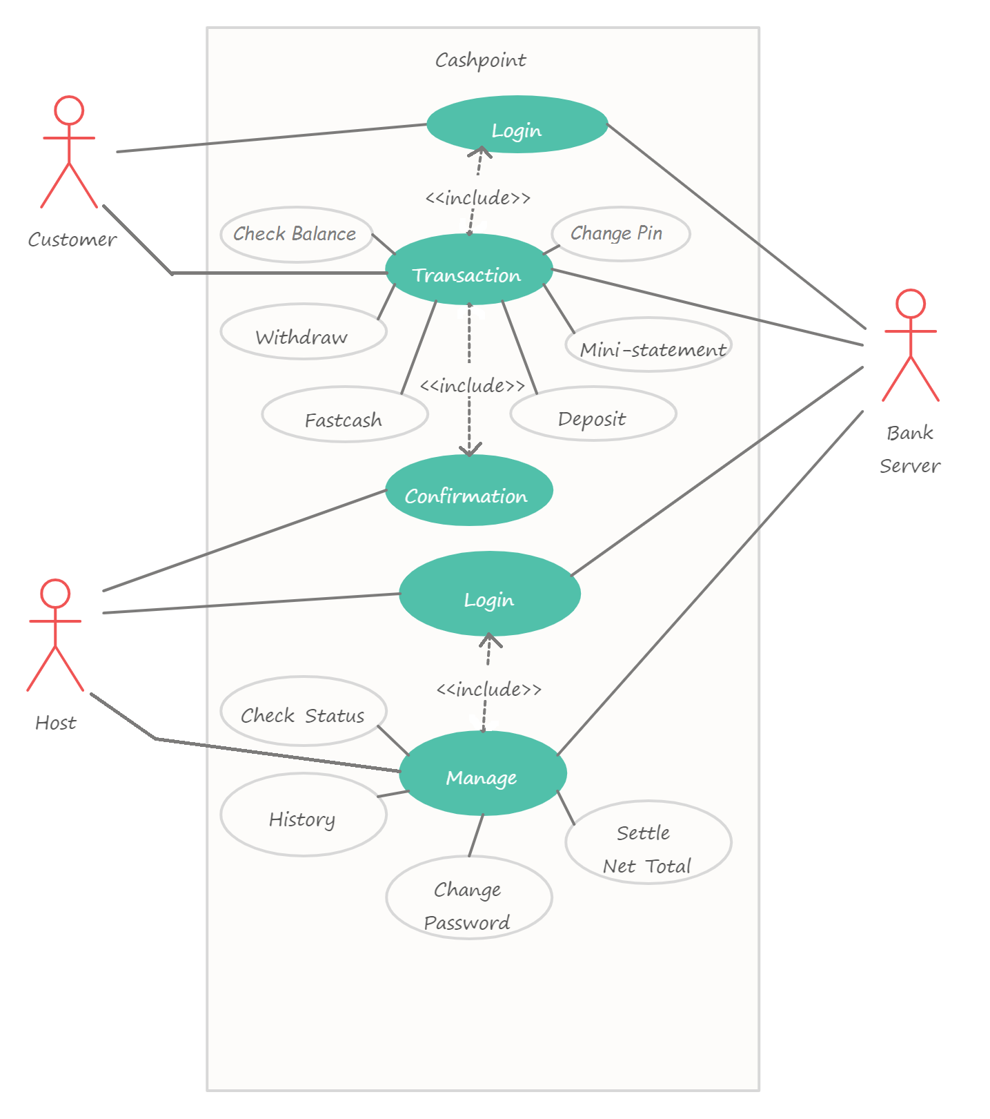
Figure 4.1: Use-Case Diagram
The above use case diagram depicts that there are three actors in the system mainly. They are Customer, Host and the Bank server. There are certain functions a Customer can perform and certain functions that a Host can perform.
The customer can login which is an included case for performing further transactions. These transactions include check balance, withdraw, deposit, fast cash, mini-statement and change pin. Further for confirmation of transaction the Host has to login to the system.
Similarly, the Host also has certain functions and privileges. It has to login compulsorily to perform these functions. The functions are check history, check status of a particular card holder, change password and calculate the net total from amount given as withdraw and received as deposit.
Thus there are primarily four use case in the system- login and logout for both customer and host, transaction for customer and management for host.

4.3 SEQUENCE DIAGRAM
The following are the sequence diagram related with the use cases:
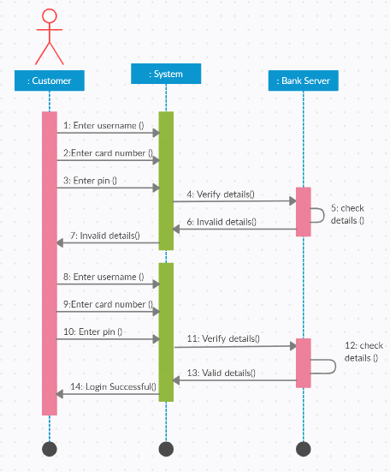
Fig 4.2: Customer Login
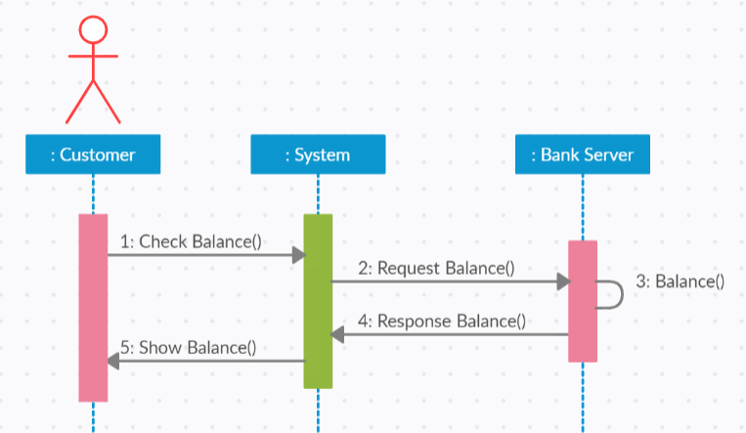
Fig 4.3: Check Balance
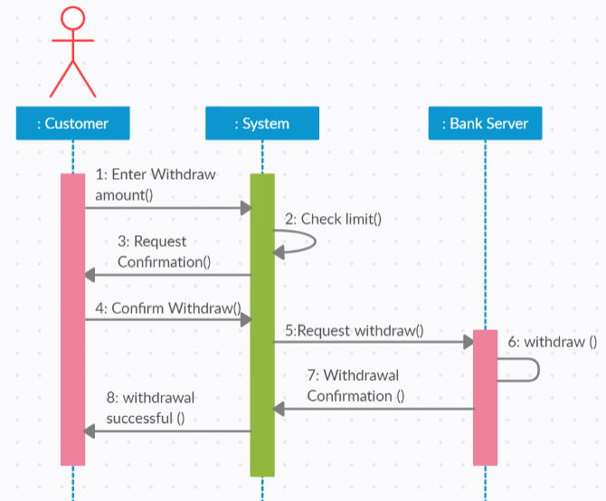
Fig 4.4: Withdrawal
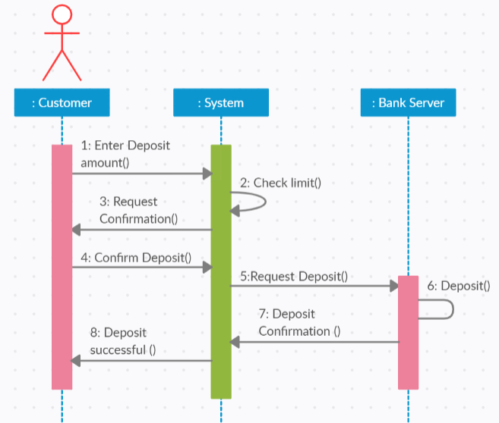
Fig 4.5: Deposit
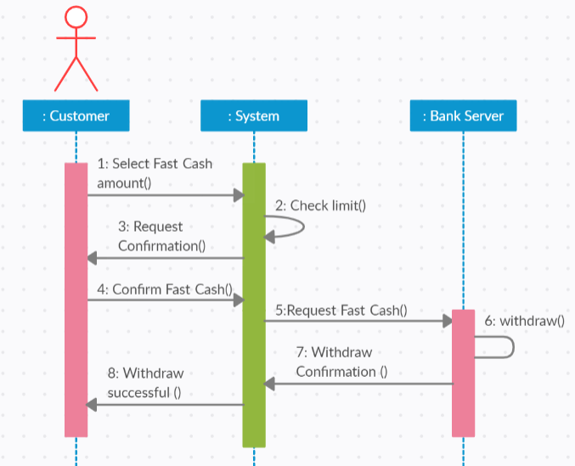
Fig 4.6: Fast Cash
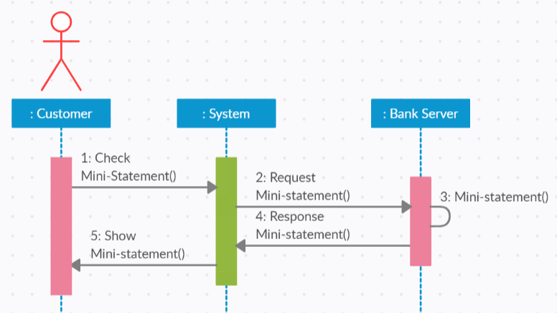
Fig 4.7: Mini-statement
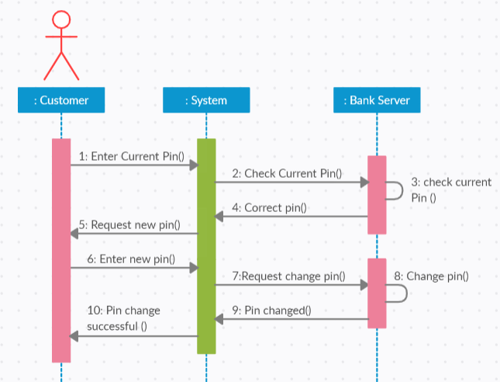
Fig 4.8: Change pin
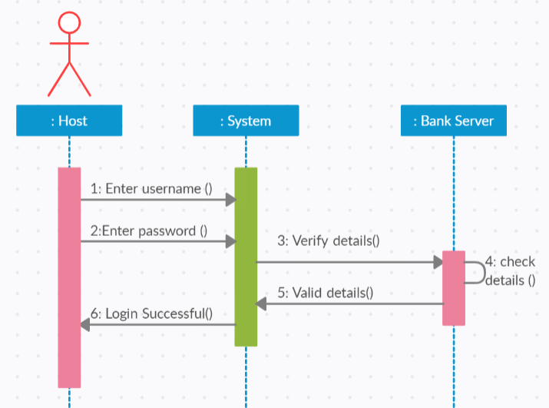
Fig 4.9 : Host Login
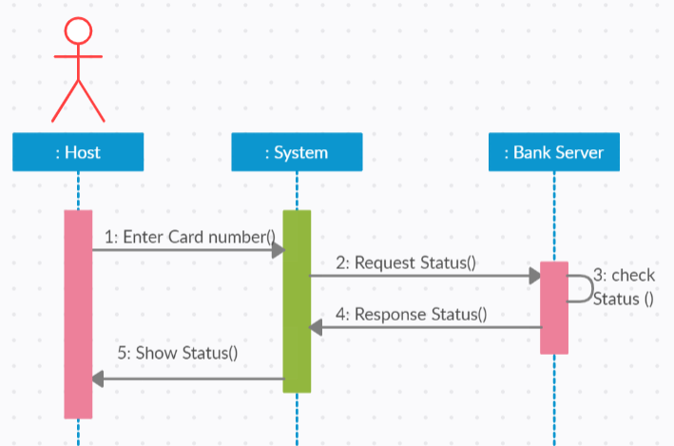
Fig 4.10: Check Status
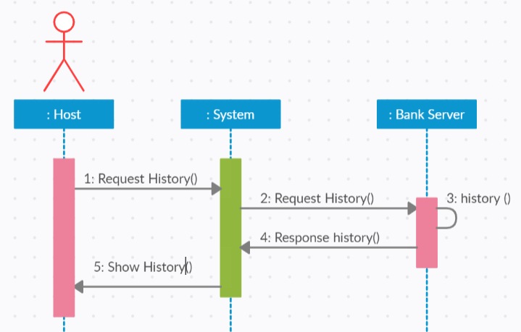
Fig 4.11: History
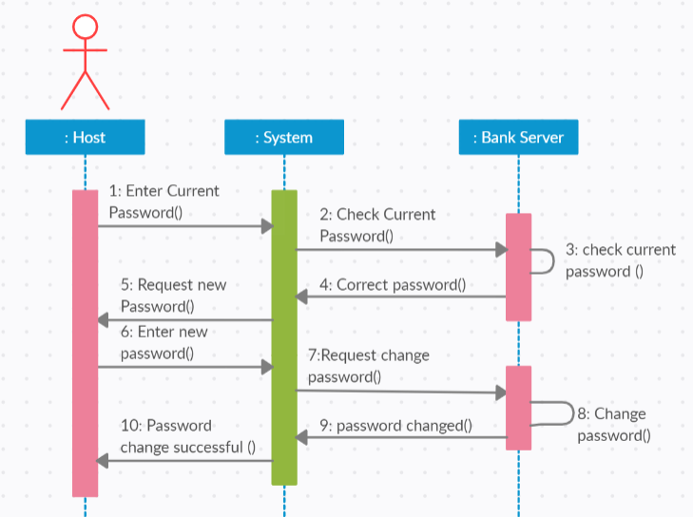
Fig 4.12: Host Password Change
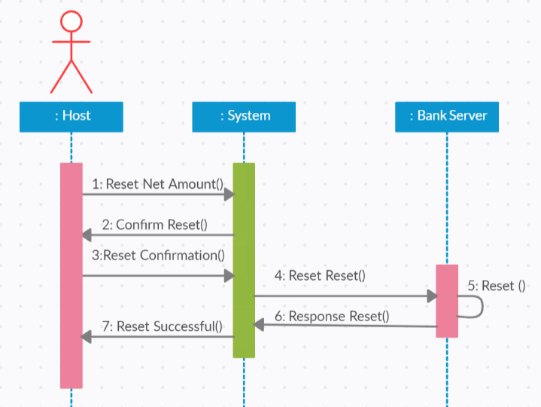
Fig 4.13: Reset Net Total

4.4 SYSTEM FLOW DIAGRAM
This is the system flow diagram of our minor project:
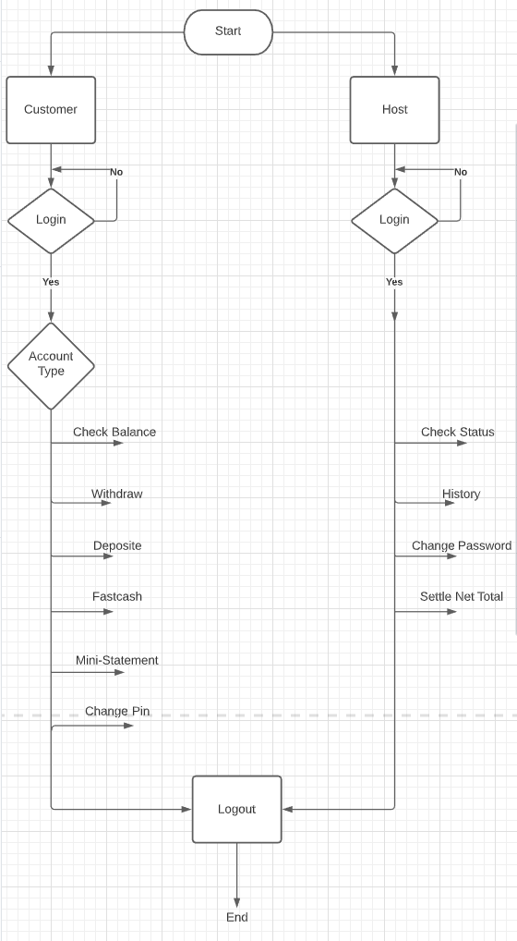
Figure 4.14 :System Flow Diagram
CHAPTER 5
SYSTEM DESIGN OVERVIEW

5.1 DATA DICTIONARY
Table Name |  | adminlogin
Description |  | This table provide the information about the login credentials of admin
Primary Key |  | username
Foreign Key |  | ---
S.No | Data Value |  | Data Type | Description
1 | username |  | Varchar(20) | It stores username
2 | password |  | Varchar(20) | It stores password
Table 5.1: Login Table
Table Name |  | admininfo
Description |  | This table provide the information about admin
Primary Key |  | username
Foreign Key |  | ---
S.No | Data Value |  | Data Type | Description
1 | Username |  | Varchar(20) | It stores username
2 | Received |  | int | It stores amount received as deposit
3 | given |  | int | It stores amount given as withdraw
Table 5.2: Admin Information Table
Table Name |  | account
Description |  | This table provide the information about the account details of customers
Primary Key |  | cardnumber
Foreign Key |  | ---
S.No | Data Value |  | Data Type | Description
1 | Username |  | Varchar(255) | It stores name of customer
2 | Cardnumber |  | Varchar(16) | It stores card number of customer
3 | Savbal |  | Int | It stores saving account balance
4 | Curbal |  | Int | It stores current account balance
5 | Withdrawlimit |  | Int | Ii stores the withdraw limit
6 | amountlimit |  | Int | It stores the deposit limit
Table 5.3 : Customer Information Table
Table Name |  | userlogin
Description |  | This table provide the information about login credentials of customers
Primary Key |  | Card number
Foreign Key |  | ---
S.No | Data Value |  | Data Type | Description
1 | Username |  | Varchar(20) | It stores name of the customer
2 | Card number |  | Varchar(16) | It stores card number of customer
3 | pin |  | Varchar(4) | It stores pin of customer
4 | lastdate |  | date | It stores last date that customer logged in
Table 5.4 : Customer Login Table
Table Name |  | history
Description |  | This table provide the information about history of the transactions of customers.
Primary Key |  | StopID
Foreign Key |  | ---
S.No | Data Value |  | Data Type | Description
1 | Username |  | Varchar(20) | It stores name of the customer
2 | Card number |  | Varchar(16) | It stores card number of customer
3 | acctype |  | Varchar(10) | It stores the account type.(saving/current)
4 | transtype |  | Varchar(10) | It stores the transaction type. (deposit/withdraw)
5 | date |  | date | It stores the date of transaction
6 | time |  | time | It stores the time of transaction
7 | amount |  | int | It stores the amount of transaction
8 | admin |  | Varchar(20) | It stores the username of adim (host)
Table 5.5 : History Table

5.2 CLASS DIAGRAM
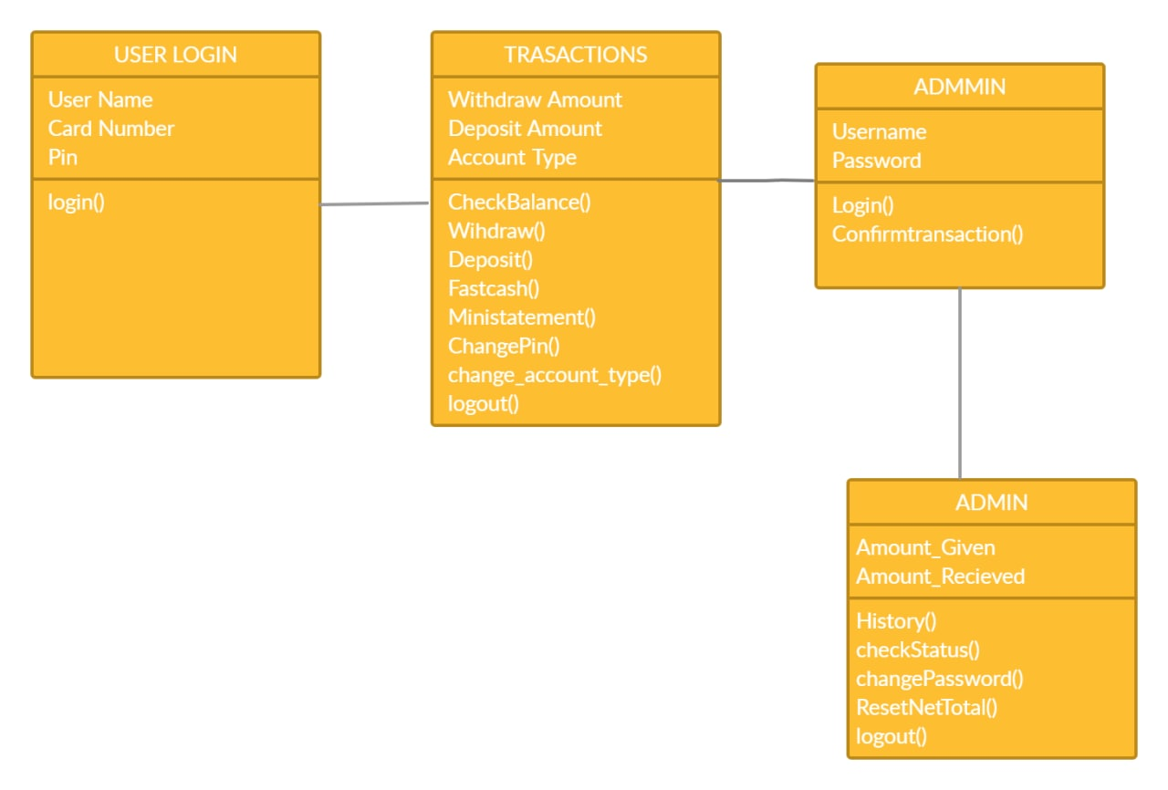
Figure 5.1 : Class diagram
5.3 DATA FLOW DIAGRAM
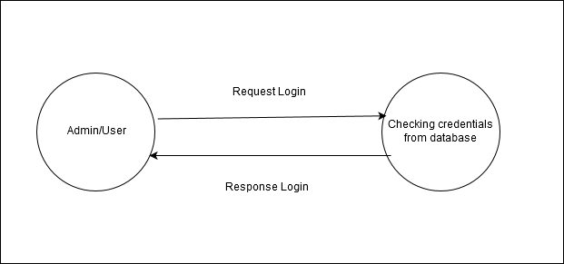
Figure 5.2 : DFD Level-0 Diagram
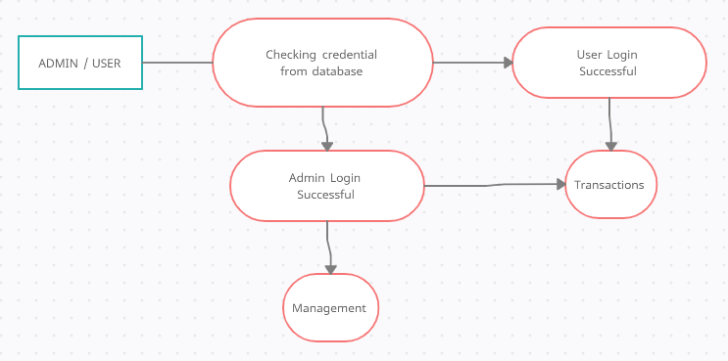
Figure 5.3 : DFD Level-1 Diagram
5.4 Extended E-R DIAGRAM
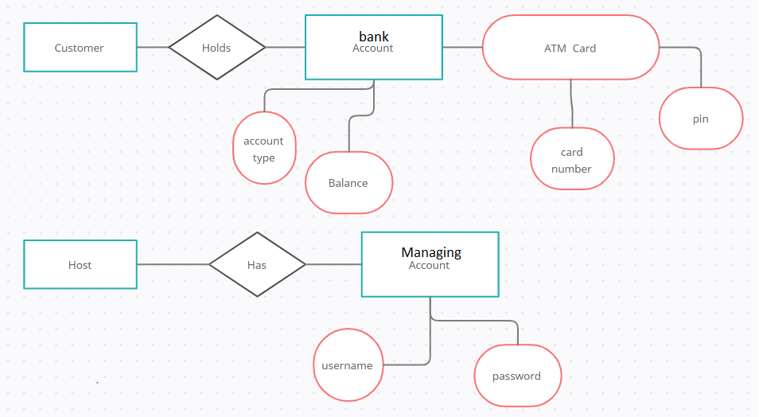
Figure 5.4 : Extended ER Diagram
CHAPTER 6
WORK PLAN AND SYSTEM DATABASE STRUCTURE

6.1 TIME FRAME WORK
S. no. | Approx. time duration  In weeks. |  | Description
1. | October( 1st week) |  | Project and synopsis planning
2. | October(2nd week) |  | Synopsis making and submission
3. | October(3rd week) |  | Information gathering.
4. | October(4th week) |  | Frontend design
5. | October (4th week) |  | Backend develoment
6. | November (1st week) |  | Sequence diagram and system flow diagram.
7. | November (2nd week) |  | Create Use case and login, forgot password.
8. | November(3rd week) |  | Testing of modules connectivity
9. | November(4th week) |  | Literature Review and GUI completion
10. | December (1st week) |  | Create ER diagram, Data flow diagram and class diagram.
11. | December (2nd week) |  | Database connectivity.
12. |  | December (2th week) |  | Performed system testing

Table 6.1: Time Frame Work
6.2 DESIGN DATABASE TABLE
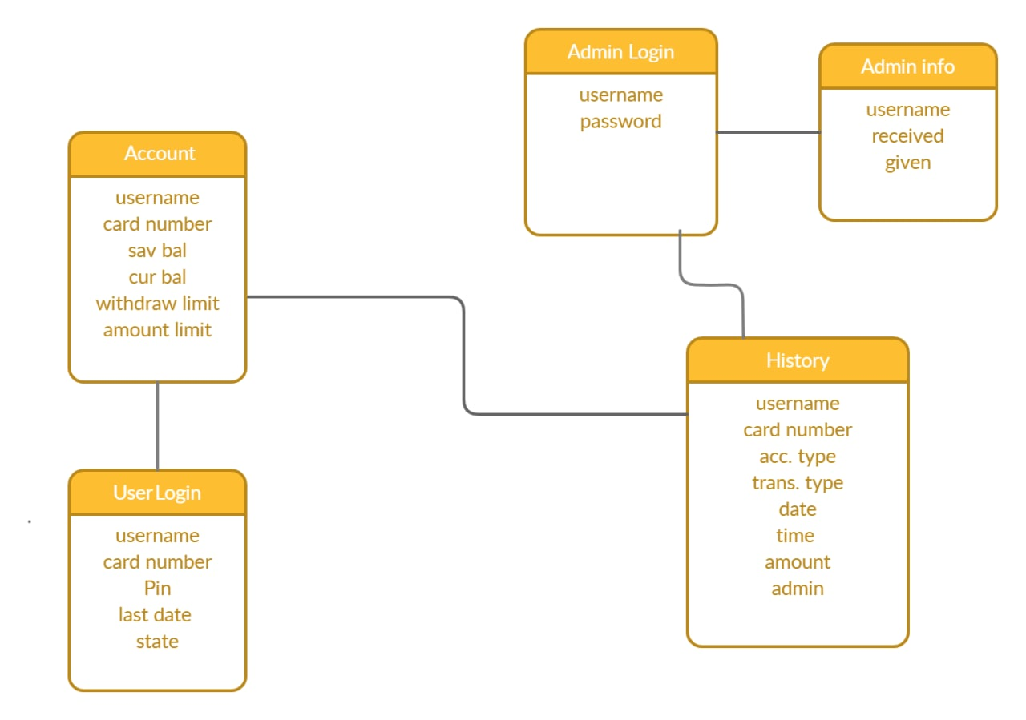
Fig. 6.1 : design database table

CHAPTER 7
IMPLEMENTATION AND TESTING

7.1 TESTING STRATEGY ADAPTED
Manual testing is performed without taking help of automated testing tools. The software tester prepares test cases for different sections and levels of the code, executes the tests and reports the result to the manager. We have done manual testing of all our modules.
We have performed both black box and white box testing of our system. Black Box Testing is carried out to test functionality of the program. It is also called ‘Behavioral’ testing. The tester in this case, has a set of input values and respective desired results. On providing input, if the output matches with the desired results, the program is tested ‘okay’ and problematic otherwise. In this testing method, the design and structure of the code are not known to the tester, and testing engineers and end users conduct this test on the software. We tested our modules for random inputs with ignorance to what the module can accept. It passed and gave expected output on testing.

White-box testing is conducted to test program and its implementation, in order to improve code efficiency or structure. It is also known as ‘Structural’ testing. In this testing method, the design and structure of the code are known to the tester. Programmers of the code conduct this test on the code. We have used Control-flow testing. The purpose of the control-flow testing is to set up test cases which covers all statements and branch conditions. The branch conditions are tested for both being true and false, so that all statements can be covered.

Also we performed unit testing of various modules and integration testing to ensure our system is working as intended and that all functionalities are satisfied.
7.2 SYSTEM TESTING
System testing of software or hardware is testing conducted on a complete, integrated
system. It checks systems compliance with its specified requirements. System testing falls within the scope of black box testing and as such should require no knowledge of the inner design of the code or logic. System testing is performed on entire system in the context of a functional requirement specification or a software requirement specification. We assure that we have done thorough system testing of our application and our application has met with most of the specified requirements. The requirements which were not satisfied will be satisfied in the next version of the software.

7.3 TEST CASES
MODULE: USER Login MODULE |  |  | TEST CASE No:1
FUNCTIONAL SPECIFICATION: Customer Login
TEST OBJECTIVE: To check whether the entered username, card number and pin is valid or not.
TEST DATA: Username, Card number, Pin
Step No. | Steps carried out | Test data |  | Expected Results | Actual Results
1 | Enter the username only and press Login Button | Username = saiyad akmal |  | Should display message “Wrong Login Details”
2 | Enter the Card number only and press Login Button | Card number = 1234567890123456 |  | Should display message “Wrong Login Details”
3 | Enter the pin only and press Login Button | Pin = 0000 |  | Should display message “Wrong Login Details”
4 | Enter wrong username and press Login button | Username = Saiyad |  | Should display message “Wrong Login Details”
5 | Enter wrong Card number and press Login Button | Card number = 12345 |  | Should display message “Wrong Login Details”
6 | Enter wrong pin and press Login Button | Pin = 1010 |  | Should display message “Wrong Login Details”
7 | Enter correct username, card number and pin and press Login Button | Username= saiyad akmal card number = 1234567890123456  Pin = 0000 |  | Should navigate to home page of customer transactions.

Table 7.1: User Login Test Case

MODULE: WITHDRAW MODULE |  |  | TEST CASE No:2
FUNCTIONAL SPECIFICATION: CUSTOMER WITHDRAWAL FRAME
TEST OBJECTIVE: To check whether the entered amount is valid or not to withdraw
TEST DATA: withdraw amount
Step No. | Steps carried out | Test data |  | Expected Results | Actual Results
1 | Enter empty field | Amount = “ ” |  | Should display warning message “Please enter amount”
2 | Enter the amount and press Submit button | Amount = 1000000 |  | Should  display  warning  message “you cannot withdraw this amount”
3 | Enter the correct amount | Amount = 10000 |  | Should  Navigate to confirm admin login page

Table 7.2: Withdraw Test Case

MODULE: Deposit MODULE |  |  | TEST CASE No:3
FUNCTIONAL SPECIFICATION: CUSTOMER DEPOSIT FRAME
TEST OBJECTIVE: To check whether the entered amount is valid or not to depsoit
TEST DATA:deposit amount
Step No. | Steps carried out | Test data |  | Expected Results | Actual Results
1 | Enter empty field | Amount = “ ” |  | Should display warning message “Please enter amount”
2 | Enter the amount and press Submit button | Amount = 1000000 |  | Should  display  warning  message “you cannot deposit this amount”
3 | Enter the correct amount | Amount = 10000 |  | Should  Navigate to confirm admin login page

Table 7.3:Deposit Test Case

MODULE:Change pin MODULE |  |  | TEST CASE No:4
FUNCTIONAL SPECIFICATION: CHANGE PIN
TEST OBJECTIVE: To check whether the pin are valid or not
TEST DATA: pin, new pin
Step No. | Steps carried out | Test data |  | Expected Results | Actual Results
1 | Enter the pin only And press Submit Button | Pin = 0000 |  | Should display  warning message  “please fill all the field”
2 | Enter the new pin only and press Submit Button | New pin = 1111 |  | Should display  warning message  “please fill all the field”
3 | Enter wrong pin and new pin | Pin = 1010  New pin = 1111 |  | Should display warning message “wrong pin”
4 | Enter correct pin and new pin | Pin = 0000  New pin = 1111 |  | Should show the message “pin changed succesfull”

Table 7.4: Change Pin Test Case

MODULE: admin Login MODULE |  |  |  | TEST CASE No:5
FUNCTIONAL SPECIFICATION: Admin Login
TEST OBJECTIVE: To check whether the entered username and password is valid or not.
TEST DATA: Username, Password
Step No. | Steps carried out | Test data | Expected Results |  | Actual Results
1 | Enter the username only and press Login Button | Username= admin | Should  display  warning  message  “please fill all the fields”
2 | Enter the password only and press Login Button | Password= admin | Should  display  warning  message  “please fill all the fields”
3 | Enter wrong username and press Login button | Username= administration | Should display warning message “Enter correct Username and password”
4 | Enter wrong password and press Login Button | Password= administration | Should display warning message “Enter correct Username and password”
5 | Enter correct password and Username and press Login Button | Username= admin  Password= admin | Should navigate to manage admin page.

Table 7.5: Admin Login Test Case
MODULE:Check status MODULE |  |  | TEST CASE No:6
FUNCTIONAL SPECIFICATION:CHECK STATUS FRAME
TEST OBJECTIVE: To check whether the entered card number is valid or not to check status
TEST DATA: card number
Step No. | Steps carried out | Test data |  | Expected Results | Actual Results
1 | Enter empty field | Card number= “ ” |  | Should not display anything on the table
2 | Enter the wrong card number and press Submit button | Card number = 1000000 |  | Should not display anything on the table
3 | Enter the correct card number | Card number = 1234567890123456 |  | Should display history on the table

Table 7.6: Check Status Test Case
CHAPTER 8
CONCLUSION AND FUTURE EXTENSION

8.1 CONCLUSION
We have developed a desktop application in Java, a platform independent software that works as an alternative to the conventional banking system.
The software is build using Java and SQL and hence is platform-independent. It is developed with all security measures keeping in mind the security and assured transaction of money with the least chance of any loophole. As an outcome dependency on Bank withdrawal counter and ATM Systems will reduce and customers will have more fast and vast options for all transactions.

8.2 FUTURE SCOPE
As an increase in requirement of cash liquidity in market and reliance on the bank withdrawal counter and ATM systems, there is a huge requirement for another and better option. Since 90% of Indians are not ready to move towards cashless system, an alternative of ATM systems is very much required. Big companies, like Bharti Airtel has come up with a similar payment banking system. This application focuses on and assures good customer bank relationship.
Expected outcome:
- Effortless and easy transactions of money.
- Alternative to the long queue of the withdrawal counter of the bank.
- Substitute for ATMs.
- Expedite the process of money transactions.
- More approach to finance and banking.
- More availability and options to ATMs.
- More access to the savings in the bank.
- Higher security and assurity of money transactions.

REFERENCES
[1] Java’s Documentation
https://docs.oracle.com/en/applications/, October 19, 2019
[2] Netbeans’ Documentation
https://netbeans.org/kb/, October 19, 2019
[3] Examples and Issue Support
https://github.com/apache/netbeans/ , October 22, 2019
[4] Java Tutorials
https://youtube.com, October 22, 2019
[5] Problem solving and error correction
https://stackoverflow.com/, October 22, 2019
[6] Netbeans Tutorials
https://youtube.com, October 22, 2019
[7] Introduction to Java swing
https://www.geeksforgeeks.org/java-swing-simple-calculator/ , October 22, 2019
[8] Reserve Bank Guidelines on payment banks https://www.rbi.org.in/scripts/bs_viewcontent.aspx%3FId%3D2900#:~:text=100%20crore.,7.5%20per%20cent%20of%20RWAs. , October 16, 2017
[9] Working of ATM System
https://ieeexplore.ieee.org/document/8906494 October 22, 2019
[10] Software Testing
https://www.softwaretestinghelp.com/types-of-software-testing , September 26, 2019
[11] How to Draw a System Flow Diagram
https://bizfluent.com/how-7181763-draw-system-flow-diagram.html , September 26, 2017
[12] Class Diagrams
https://www.geeksforgeeks.org/unified-modeling-language-uml-class-diagrams , 2019
[13] Data Dictionary in DBMS
https://www.includehelp.com/dbms/data-dictionary-in-dbms.aspx , 2019
[14] Sequence Diagrams
https://www.geeksforgeeks.org/unified-modeling-language-uml-sequence-diagrams , 2018
[15] Icons and Images
https://nucleoapp.com/ ,
[16] Study of Airtel Payment bank
http://www.managementjournal.info/index.php/IJAME
[17] Creatly tool for diagrams
https://creately.com/
[18] Learn Java GUI Applications 11th Edition: A JFC Swing Tutorial Philip Conrod, Lou Tylee 2019
[19] Java Swing Developer RED-HOT Guide, Red-Hot Careers 2018
[20] Design Patterns: Elements of Reusable Object-Oriented Software Addison-Wesley Professional Computing Series Old Edition

APPENDIX A
Screenshots
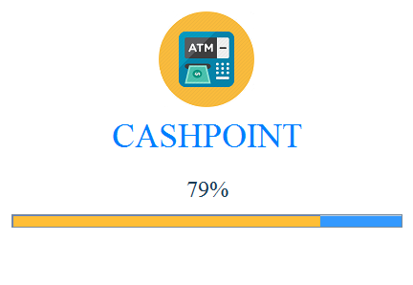
Fig 9.1 : Splash Screen
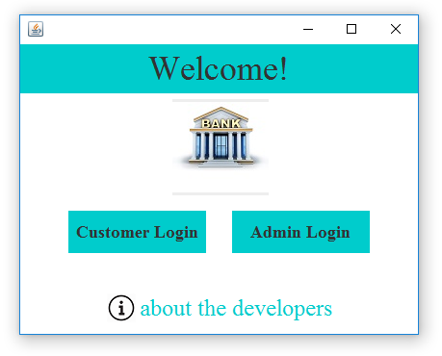
Fig 9.2 : Navigation Screen
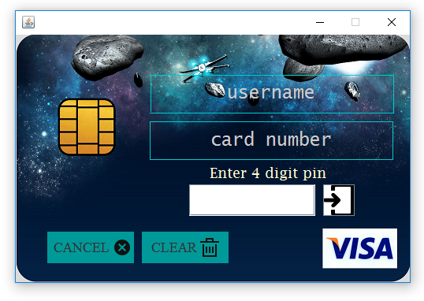
Fig 9.3 : Customer Login page
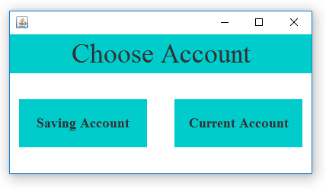
Fig 9.4 : Choose account page
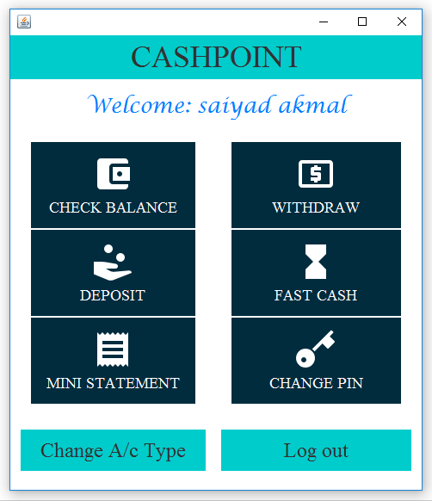
Fig 9.5 : Customer Home Screen
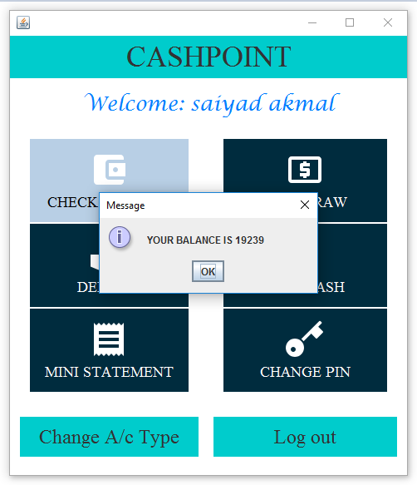
Fig 9.6: Check Balance Screen
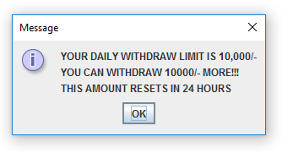
Fig 9.7 : Withdraw Warning message
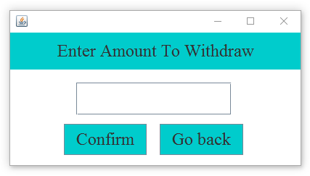
Fig 9.8 : Withdraw Screen
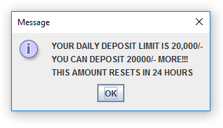
Fig 9.9 : Deposit Warning message
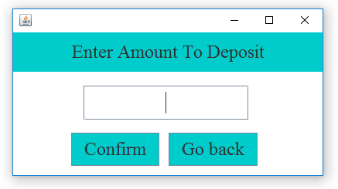
Fig 9.10 : Deposit Screen
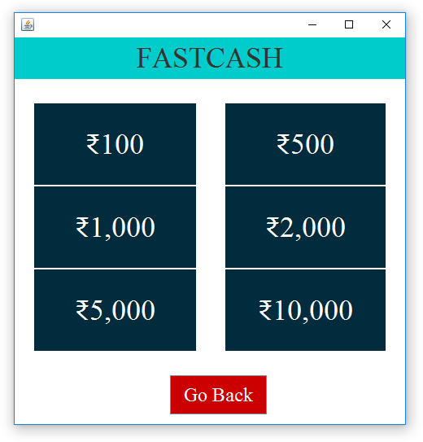
Fig 9.11 : Fast Cash Screen
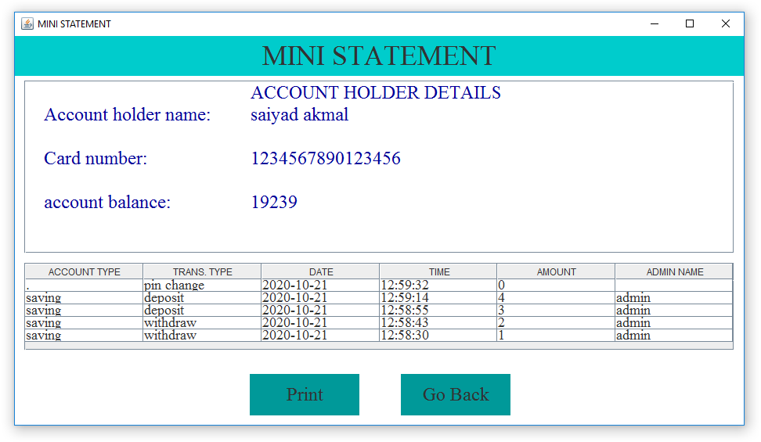
Fig 9.12: Mini-statement Screen
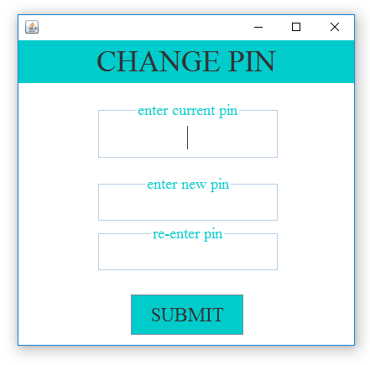
Fig 9.13: Change Pin Screen
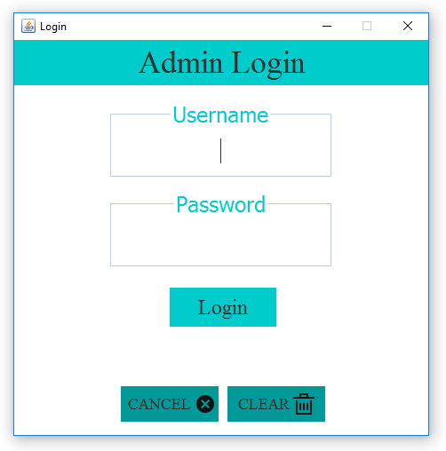
Fig 9.14: Admin Login Page
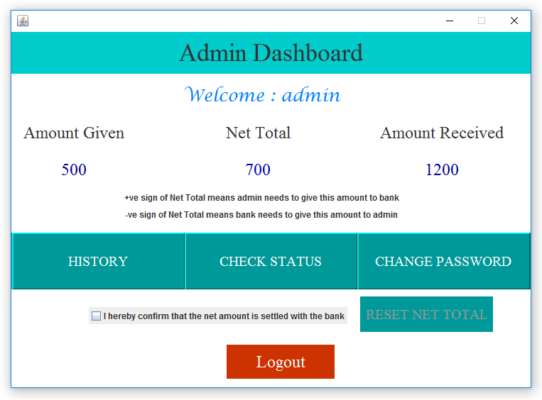
Fig 9.15: Admin Home Screen
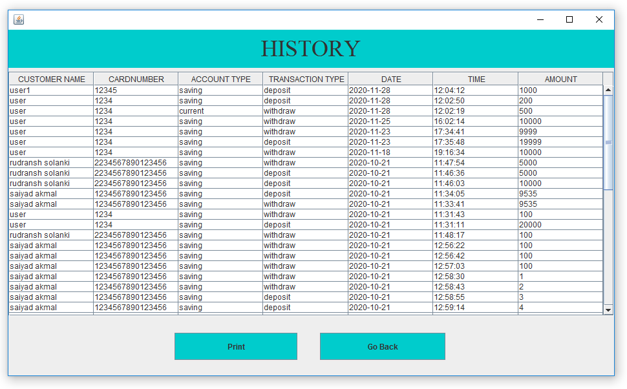
Fig 9.16 : History Table Screen
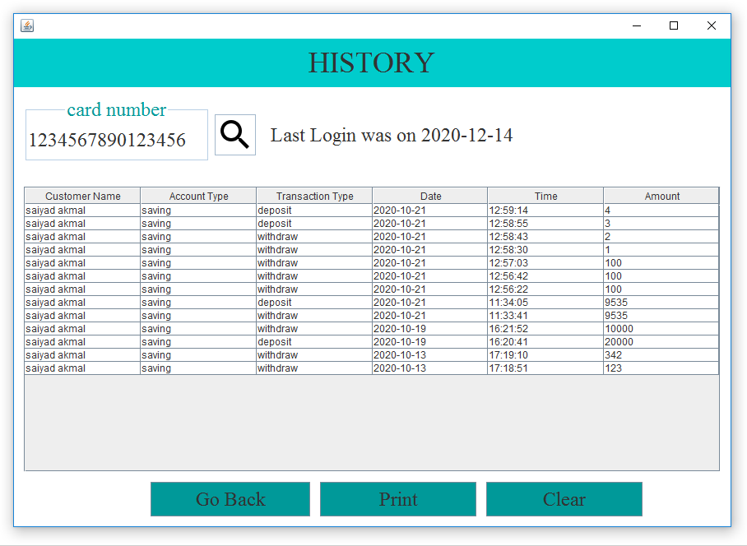
Fig 9.17: Check Status Screen
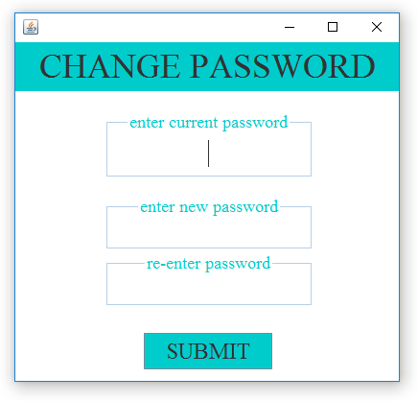
Fig 9.18: Change Admin Password Screen

APPENDIX B
Filled Weekly Project Work Progress Sheet

